



**Switching from MySQL to Microsoft SQL**

**Created By: Rodrigue Noubissie**

**Last Updated: 14/09/2018**

TOC

**Introduction** 3

**Prerequisites:** Ensure Connection to Microsoft SQL Server 3

**Switching to Microsoft SQL Server Database** 5

**Removing the MySQL dependency** 8

**Removing MySQL** 10

# **Introduction**

This simple guide explains how to switch from MySQL to Microsoft SQL in an existing OLConnect installation.

The quick guide is as follow:

* Ensure the Microsoft SQL Database can be connected to remotely or from an external application
* Switch to Microsoft SQL Database
* Remove the dependency for MySQL
* Uninstall MySQL

As always, it is recommended to back up the system before applying any changes.

# **Prerequisites:** Ensure Connection to Microsoft SQL Server

To ensure a successful connection to Microsoft SQL Server, the below configurations apply on the machine running your Microsoft SQL Server instance:

1. Enable mixed mode security when installing Microsoft SQL Server so that you can connect to the database using a SQL user name and password.
2. The JDBC driver only works with the TCP/IP protocol. Therefore, enable the TCP/IP Protocol from the SQL Server Configuration Manager that ships with Microsoft SQL.

Look under:

SQL Server Network Configuration > Protocols for *SQL InstanceName >* TCP/IP > Enable

1. Set the TCP Port by right clicking on “*TCP/IP*”, then click on “Properties” and clicking on the “*IP Addresses*” tab. The Default port is ***1433***. To use Dynamic Ports, set the Port to 0 in the TCP Dynamic Ports entry
2. Re-start the SQL Server service to apply the changes.

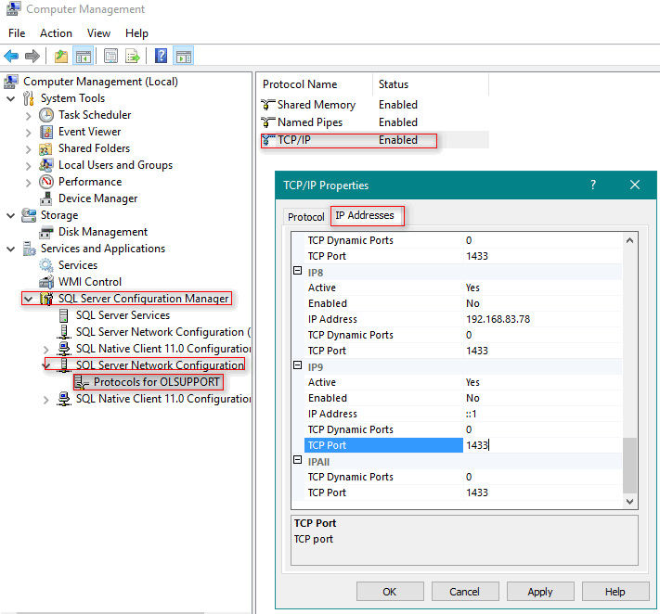

1. Add TCIP Port 1433 and UDP Port 1434 in your firewall Inbound Rules. If you are using any other ports, makes sure to add them to your firewall inbound rules.

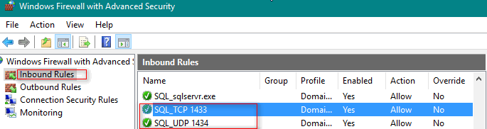

1. Allow remote connection to the SQL Server. Log into your Microsoft SQL Server instance from SQL Server Management Studio. Right click the server and click on “*Properties”.* Navigate to “*Connections”* and ensure that “*Allow remote connections”* to this server is checked.

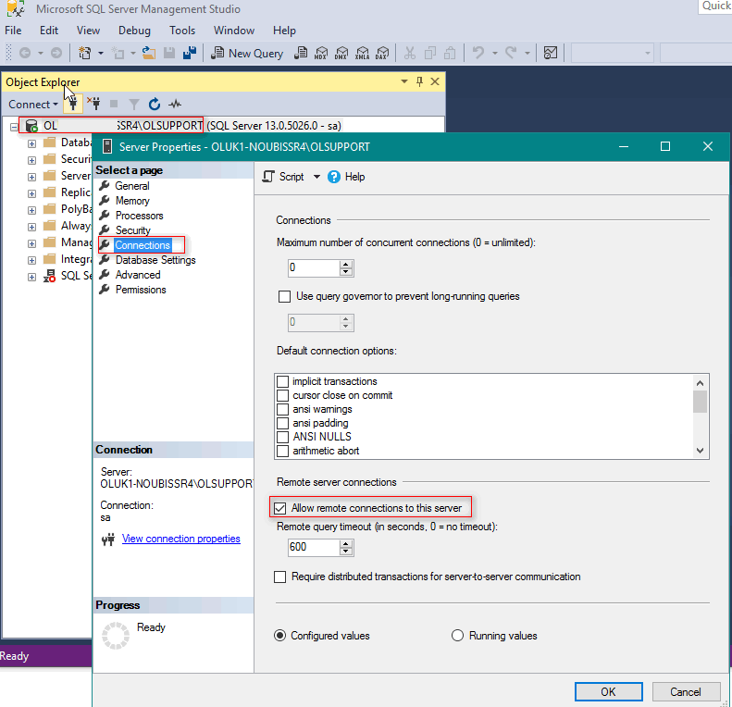

# **Switching to Microsoft SQL Server Database**

To switch to Microsoft SQL Server:

* Open the Connect Server Configuration tool. By default, this is located in C:\Program Files\Objectif Lune\OL Connect\Connect Server Configuration\ ServerConfig.exe
* Click on the Database Connection page
* Set the Database Vendor to *Microsoft SQL Server* from the dropdown list
* Enter the Hostname, SQL account username and confirm its password.
* Set the schema to *objectiflune*
* The default port for Microsoft SQL Server is 1433; however, you can use the same port that you have configured earlier in the Microsoft SQL Server Configuration Manager. You may set the Port to 0 if SQL Server runs on dynamic ports.
* To specify the SQL Server Instance Name, click the *Add button* under the *Custom database parameters* section and add the property *instanceName*
* Click on *Test Connection*; then *Apply* and restart the OLConnect_Server service to apply the changes (Control Panel > Administrative Tools > Services > OLConnect_Server > Restart).

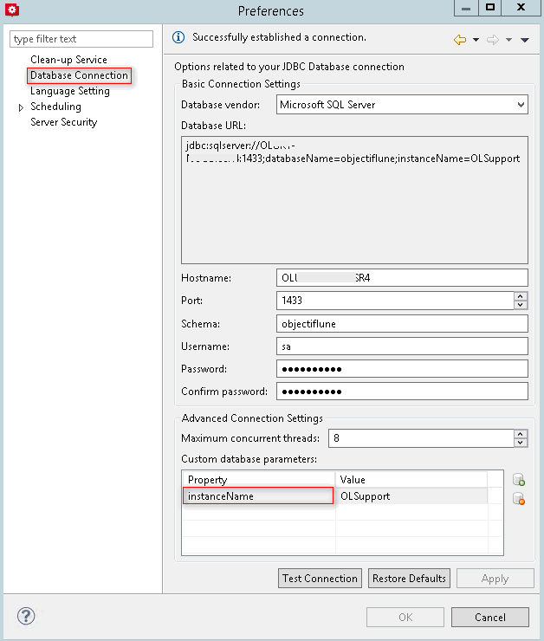

* Once the OLConnect_Server service restarts, head back to Microsoft SQL Server Management Studio, then refresh the SQL Server and verify that the *objectiflune* database now appears in the list of databases.

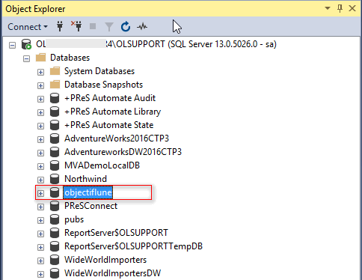

* Start Connect Designer and run an example template to generate output, and then run another test in Workflow to make sure everything works as expected with Microsoft SQL.

# **Removing the MySQL dependency**

A service dependency between OLConnect_Server and OLConnect_MySQL was removed in v2018.1 and there are arguments on whether it should be brought back. To check whether this dependency exists in your installation:

* Right-click the OLConnect_Server service and click on properties

(Control Panel > Administrative Tools > Services > OLConnect_Server > right-click > Properties)

* Click on the Dependencies tab and check whether the OLConnect_MySQL is a dependent service

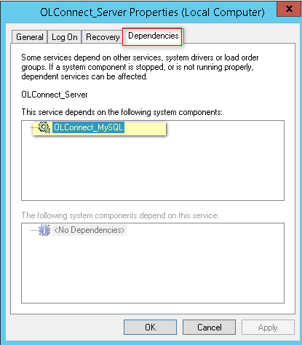

Follow below steps to remove this dependency:

* Open a command-line prompt with full administration rights.
* Enter the command *sc config OLConnect_Server depend= /.* This removes the dependency.

Please be aware: The key word *depend* must be followed immediately by the equal sign, but between the equal sign and the forward slash there must be a space.

To restore the dependency use: *sc config OLConnect_Server depend= OLConnect_MySQL*

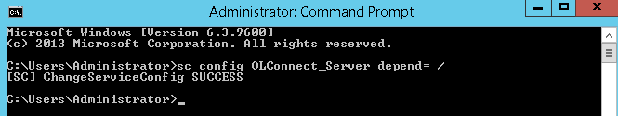

* Check the dependency has effectively been removed by inspecting the Dependencies tab of the OLConnect_Server service again:

(Control Panel > Administrative Tools > Services > OLConnect_Server > right-click > Properties >Dependencies)

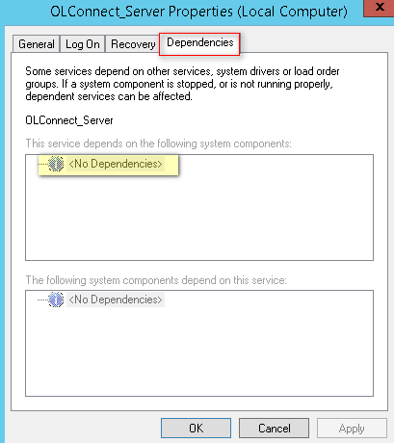

* Once the dependency has been removed, stop the OLConnect_MySQL service.

(Control Panel > Administrative Tools > Services > OLConnect_MySQL > right-click > Stop)

# **Removing MySQL**

This optional section provides additional information to users who wish to remove MySQL from the system.

* Backup your system and its data
* Backup the following folders:

C:\ProgramData\Objectif Lune\OL Connect\MySQL (MySQL Data Folder)

C:\Program Files\Objectif Lune\OL Connect\MySQL Product (MySQL App folder)

C:\Users\<username>\connect\MySQL (this folder may exist on some older installations)

* Open a command-line prompt with full administration rights.
* Execute the following commands to stop and remove OLConnect_MySQL service.

*net stop OLConnect_MySQL*

*sc delete OLConnect_MySQL*

* If the user does not need the MySQL data, remove the following folders:

C:\ProgramData\Objectif Lune\OL Connect\MySQL (MySQL Data Folder)

C:\Program Files\Objectif Lune\OL Connect\MySQL (MySQL App folder)

C:\Users\<username>\connect\MySQL (this folder may exist on some older installations)